RADAR SYSTEM OVERVIEW

The radar system is composed of four main sections: power conditioning, high-speed mixed-signal section, RF section, and antennas. A simplified system block diagram is shown in Fig. 1. The power section conditions the signal from the aircraft’s DC generator and produces all the voltages required for operation. It consists of an external uninterruptible power supply (UPS), power filter modules, and a bank of switching DC-DC converters and regulators. The high-speed mixed signal section is based on modules from the Arena 300 series from Remote Sensing Solutions (RSS) [1]. Besides custom clock generation/distribution circuitry synchronous to a master 10-MHz source, this section includes an arbitrary waveform generator (AWG), a central timing unit (CTU) for control and synchronization, and two high-speed analog-to-digital converter (ADC) channels. The AWG runs at 2 GSa/s to directly synthesize wideband pulsed chirp signals in the 600 MHz to 900 MHz range. The ADCs operate at 1 GSa/s with an internal clock divider. We use x2 onboard decimation to achieve an effective sampling rate of 500 MSa/s. The radar records 16-bit I/Q baseband samples with a coordinated universal time (UTC) stamp from an onboard global positioning system (GPS) receiver. We use 48 hardware presums to reduce the data rate and enable multi-hour acquisitions (data rate 25 MB/s). The radar is controlled from a laptop computer running a custom graphical user interface. The RF section consists of a high-power transmit/receive (T/R) module and a dual-channel analog receiver. The T/R module is a custom design with low insertion loss that allows sharing the same antenna for transmission and reception, handling high peak RF power levels with a duty cycle of up to 10%, and toggling between states with sub-microsecond speeds [2]. The analog receiver has two gain settings to maximize the system’s dynamic range. The high gain setting (46 dB) is used to amplify weak returns from the ice bed and sub-surface reflectors. The low-gain setting is adjustable (4, 8, or 16 dB) and allows capturing strong radar returns from the ice surface. The output of the receivers are recorded with the two separate ADC channels mentioned above. Pre-select and anti-aliasing filters are included in this section to achieve high-frequency selectivity and minimize potential interference with other instruments onboard. We also included a 40-dB dual directional coupler at the output of the T/R module to monitor the radar signal as it travels to and from the antenna. The output of the coupler is attenuated and then supplied to the receiver via a calibration switch to continuously monitor the phase response of the system. The antenna is a custom array of 4 Vivaldi elements. The antenna design is based on the work by Lewis et al. [3] with some modifications for enhanced RF power handling and airworthiness. The total gain of the antenna array is ~6 dBi.

Table 1: Summary of system parameters
Parameter | Value | Units
Operating frequency range | 600 to 900 | MHz
Range resolution (air, no window) | 0.5 | m
Peak transmit power | 400 | Watt
Pulse duration (programmable) | 2 | μs
Pulse repetition frequency (typ.) | 25 | kHz
Sampling rates | 2.0 (AWG) / 1.0 (ADCs) | GS/s
Transmit channels | 1
Receive channels | 2 (low-gain/high-gain)
Antenna type | Vivaldi array
Antenna array gain | ~6 | dBi
Radar system weight | 25 | kg
Power consumption | ~300 | Watt

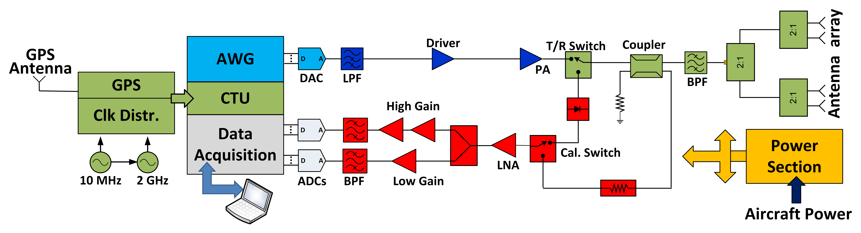

Fig. 1: Simplified system block diagram.
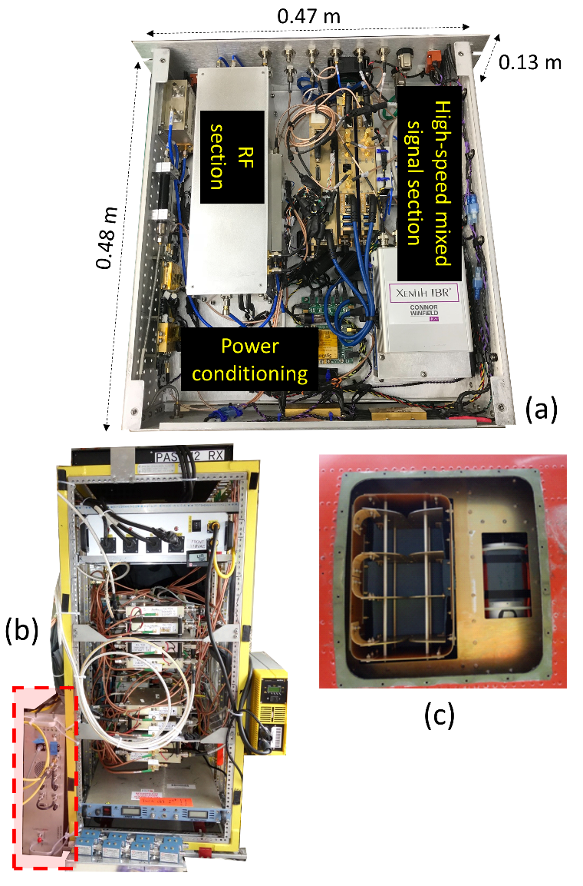
Fig. 2: Photographs of the main radar chassis (a); radar chassis (highlighted in red) installed in the instrument rack inside the Twin Otter Aircraft (b); and nadir-looking antenna array (c).

[1] Online: http://remotesensingsolutions.com/arena/
[2] F. Rodriguez-Morales et al., High-Power, Wideband Transmit/Receive Switches and Modules for Ice Sounding/Imaging Radar, Microwave Journal, May 2016, pp. S6-S18.

[3] C. Lewis, et al., Airborne fine-resolution UHF radar: an approach to the study of englacial reflections, firn compaction and ice attenuation rates, J. Glaciology, Vol. 61, No. 225, 2015, pp. 89-100.

