Structural Design Requirements
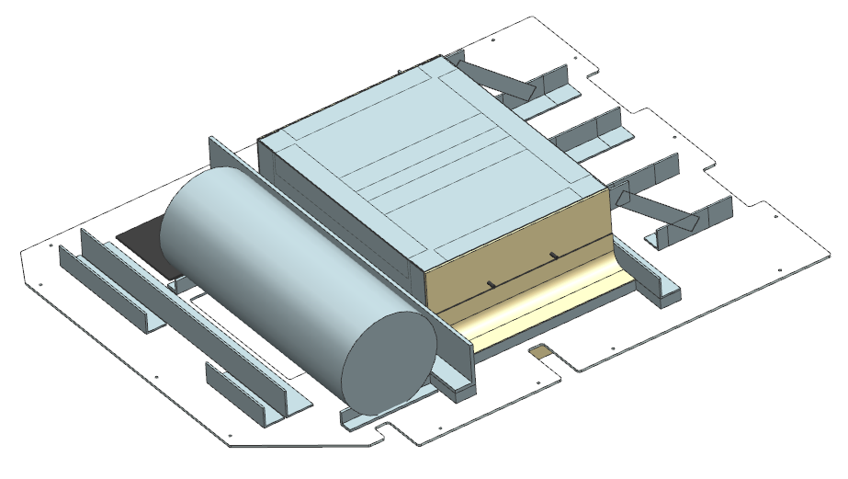
Most of the structural design requirements for this system were derived from instrument performance. A major design driver was minimizing the deflection of the mounting plate around the LIDAR. The maximum deflection of the LIDAR could not increase by more than 0.1 mm, compared to the previous LIDAR mount. The previous LIDAR mounting plate was analyzed for comparison to verify the maximum deflection of the LIDAR would not exceed this limit under any loading condition.
Figure 1: Final LIDAR and Accumulation Radar Antenna Mount Design
The design was also heavily influenced by the geometry of the Twin Otter camera bay. The perimeter geometry of the mounting plate was fixed based on the dimensions of the Twin Otter camera bay and the corresponding hardpoints. For mounting, the maximum load on the hardpoints could not exceed 120 lbs., as outlined in the British Antarctic Survey (BAS) documentation¹. Also, since the mounting plate is integrated directly into the structure of the aircraft, ultimate load failure analysis was performed with a factor of safety (FS) of 1.5.
Another major contributing factor to the design was the schedule of the project, requiring a design which could be easily manufactured. The design included stock sizes of metallic components made of 2024-T3, 2024-T351, and 6061-T6 which were readily available or could be acquired rapidly. Composite components were used in regions parallel to the antenna array and below the mounting plate to mitigate any reduction in antenna performance. The composite components were made of S2-glass fiber and the geometry was based on existing composite tooling for rapid manufacturing.

Loads
Five different inertial load cases were considered during the analysis of the combined LIDAR and accumulation radar antenna array system. The load cases were derived from both the BAS documentation¹ and the Federal Aviation Administration’s (FAA) crash loads documentation². The most extreme load case in each direction was selected for a conservative analysis approach. The final load cases and the corresponding sources are summarized in Table 1. The 1G downward load case was used to determine the weight of the final design of the mounting plate.

Table 1: Inertial Load Cases for Analyzing the BAS Twin Otter Camera Bay
Load Case | Inertial Loads | Source^{1,2}
1 | 10.35G Forward | BAS
2 | 1.725G Rearward | BAS
3 | 5.175G Upward | BAS
4 | 6G Downward | FAA
5 | 3G Sideward | FAA
- | 1G Downward | -

Analysis and Verification
The geometry of the camera bay plate, LIDAR, accumulation radar antenna array, and antenna housing was created in Unigraphics NX 12³. MSC Patran/NASTRAN software⁴ was used to create the finite element models for both the previous LIDAR mount and the final system.

Finite Element Analysis
Every structural component was evaluated for all load cases using finite element software MSC Patran/NASTRAN. Two-dimensional shell elements were used to model all components except for metal extrusions. Extrusions were modeled as one-dimensional beams. The inertial loads were applied to the finite element model as global loads and every component was analyzed for all possible failure modes (tension, compression, buckling and shear). A factor of safety of 1.5 was added to the Margin of Safety (MS) calculations.
A maximum stress criterion was used to evaluate the fiber reinforced structures against failure. Open-hole allowables were used for the analysis of composite structures. A-basis allowables outlined in Military Handbook 5H⁵ were used for all metal parts. For a conservative approach, the lower value between the L and LT basis was used for MS calculations. Standard MS calculations were performed using Equation 1. All structures were sized to a positive margin of safety.

$MS= \frac{σ_{allowable}}{{1.5*σ}_{actual}}-1$ (1)

A static analysis was performed for each load case to analyze the maximum deflection of the system. The deflection of the mounting plate had to remain within 0.1 mm of the maximum deflection of the previous LIDAR mounting plate. Table 2 includes the increase in deflection of the mounting plate for each load case. The weight of the final design is 66.3 lbs.

Table 2: Increase in Maximum Deflection of LIDAR mount
Load Case | Change in Maximum Deflection (mm)
10.35G Forward | 0.005
1.725G Rearward | 0.001
5.175G Upward | 0.032
6G Downward | 0.036
3G Sideward | 0.000

High margins of safety were calculated for all possible fastener locations in both the metallic and composite components. Because of the high margins of safety a minimum number of fasteners were required, and the main design concern was edge distance and fastener-to-fastener spacing due to volume constraints of the system. All fastener patterns were designed to adhere to appropriate minimum edge and fastener-to-fastener spacing rules. For metallic and composite materials, fastener-to-fastener spacing was required to be 4D and 5D, respectively. Minimum edge spacing for composite materials was required to be 3D, while minimum edge spacing for metal materials was required to be 2D.

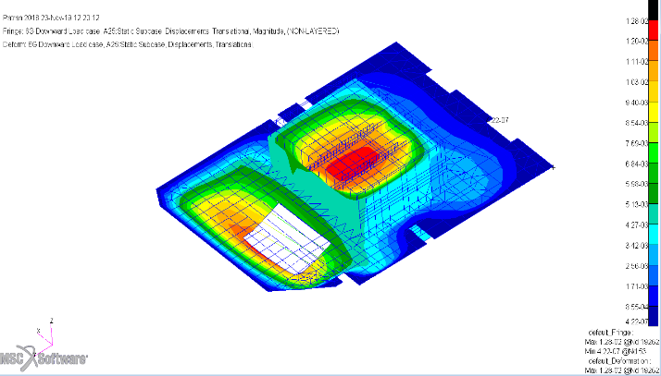
In addition to the static analysis, modal analysis was performed. For the modal analysis, all modes were required to be outside the Blade Passage Frequency (BPF) of the Twin Otter by 5 Hz. The blade passage frequencies used for this analysis were 81.4 Hz, and 99 Hz, each corresponding to a different mode of flight: Normal Operations, and Climb, respectively. When performing the analysis, bounds were set for the modal analysis to only analyze frequencies in a range around the blade passage frequencies.
Figure 2: Example of a Maximum Deflection Plot for the Final system

Modal Testing
The finite element model of the system was used to predict the natural frequencies which were close to the blade passage frequencies and their corresponding mode shapes. The first modes found in the finite element model were bending modes for the lid of the antenna housing. The finite element analysis did not show any structural resonance frequencies in the ranges of 81.4 ± 5 Hz, or 99 ± 5 Hz.
The final system was subjected to modal testing. A mechanical shaker was used to generate random excitation. The input force was measured by a force transducer and the response was measured by several accelerometers. For modal testing, the shaker and the accelerometers were positioned based on the responses generated in the finite element analysis. Table 3 shows the results of the modal testing.

Table 3: Predicted and Measured Modal Response
Blade Passage Frequency (Hz) | Predicted Frequency (Hz) | Frequency Measured (Hz)
81.4 | 87 | 76.6, 89.7
99 | 92 | 89.7, 107

After performing modal testing only one resonance was observed within 81.4±5 Hz, at 76.6 Hz. The tests verified there were no structural resonances in the 99±5 Hz range. During modal testing the LIDAR was not available and an aluminum beam was added in place of the LIDAR. This was taken into account in the finite element analysis. The modal testing produced similar results to what was predicted and it also produced extra modes. The probable cause of these extra frequencies is a difference in the boundary conditions between the finite element model and the actual test setup. Overall, the predicted and measured results provide sufficient validation of the structural analysis.

References
- British Antarctic Survey: Natural Environment Research Council, “Installation of Science/Survey Equipment in BAS Aircraft as Role Change Equipment”, Issue 8, pp. 8, 25 January 2018.
- “Part 25 Airworthiness Standards: Transport Category Airplanes: Subpart C – Structures”, Title 14: Aeronautics and Space, Electronic Code of Federal Regulations: e-CFR.
https://www.ecfr.gov/cgi-bin/text-idx?SID=0b599220672f917a3b5342fad125202c&mc=true&node=sg14.1.25_1537.sg15&rgn=div7
- “Unigraphics NX”, Version 12, Siemens, Munich, Germany
- “Patran/Nastran”, Version 2016/2018, MSC software, Santa Ana, California
- “Military Handbook Metallic Materials and Elements for Aerospace Vehicle Structures”, Department of Defense, MIL-HDBK-5H, 1 December 1998.

