DC8 MCoRDS Manual
For operation with QLook version 1.3.XX

- MCoRDS Radar

MCoRDS for the DC8 has 5 TX/RX channels and 3 EMI channels. For low altitude flights the radar is configured to transmit two different waveforms. Waveform one is a single 1us pulse which is meant to record the surface. Waveform two is sixteen 10us pulses which are coherently integrated to sound the bed. For high altitude flights, the radar is configured to transmit a 30us pulse which is used for surface and bed detection.

The radar requires 2 different files in order to operate properly. The first is the configuration file called “config_radar.txt”, the second is a waveform envelope shaping file called “Wavegen_Shape8.wf”. The config_radar.txt file is generated by the QLook GUI but can also be hand modified (human readable, see Appendix I). The Wavegen_Shape8.wf is generated via Matlab and is not human readable.

For the Greenland 2010 mission all Wavegen_Shape8.wf files that will be needed will be pre-generated and loaded into the radar control slice. The operator must manually swap this file out when the following parameters are changed.

Transmit weighting is changed
This will only occur on low altitude flights where the transmit weights are
either full power or Blackmann
Base pulse length is changed
This will occur when switching for low altitude config files to high
altitude config file.

Appendix I and II shows the configurations files used in the Chile 2009 DC8 flights. These config files are valid for MCoRDS comprised of digital chassis 1, TX chassis 1, RX chassis 1, and PA chassis 2. Swapping out chassis will result in the need to recheck (and possibly re-perform) amplitude and phase matching across channels.

- Config_radar.txt Settings

The following breaks down each setting in the configuration file, these also apply to the GUI radar settings in the QLook program.

Sample Frequency: Do not change.

DDS Frequency: Do not change.

PRF Output PRF of the radar, this applies to all channels.
Change as needed to increase or decrease the record speed.

I/O update time: Do not change.
This is the amount of time between the start of the PRF trigger and
output of the chirp signal from the DDS.

Base Pulse Length Use 1us for low altitude, 3us for high altitude flights.
This is the base duration programmed into the DDS which is then
multiplied by the “Waveform Length Mult” (a parameter that is specific to each waveform) to yield the final DDS output chirp duration.

HI CH ENA Must be on for QLook scrolling echogram and ascope to work.
Must be on for QLook recording to record data.
Enables the high integration channel which is the channel that siphons off the raw data (written to hard drives) for the QLook program.

HI CH RATE Do not change.

HI CH WFNUM Selects the waveform who’s data is used in the QLook.
To change this parameter you must first stop the radar, change it,
then restart the radar.

HI CH PRE CNT Do not change.

HI CH RO CNT

Multichip Sync Do not change.

----------------------------------------------------------------------------------------------------------
The three following signals are for the Trigger output which is meant to be used to slave the LVIS system with MCoRDS to prevent crosstalk. This trigger signal is a multiple of the radar’s PRF. This was not used in the 2009 Chile flight.

Trig Out Div Divisor on PRF
This sets the freq of the output trigger signal

Trig Out Cnt High The amount of time trigger will remain in 1 state before switching
to next state. The state is linked to “Trig Out Inv”.
Each count is 18ns long.

Trig Out Inv False – signal will remain HIGH for the duration of “Trig Out Cnt
High” and low for the remaining period.
True – signal will remain LOW for the duration of “Trig Out Cnt
High” and high for the remaining period.
----------------------------------------------------------------------------------------------------------
ADC Bypass 0 = normal mode, ADC will digitize input signal into digital
chassis
1 = bypass mode, a digital ramp signal will replace the output of
the ADC inside the digital chassis. This also applies to the
high integration channel and so QLook (raw linear acscope)
should so a ramp.

DDS Power Level Settings
DDS# Amplitude Keep the values on this as low as possible.
Range of usable values 0 to 255. 0 = -7dBm 255 = +4dBm (may not be linear). Use this for fine tuning channel amplitude
balancing. Note: If this is set to above -3dBm it will saturate the
power amp chassis.
This balancing applies to all waveforms.
------------------------------------------------------------------------------------------------------------
From here on are the settings for individual waveforms. Note that each waveform has the same set of parameters. Adding more waveforms is done on the QLook GUI.

Waveform # The waveform number. MCoRDS plays waveform 1 followed by
2, etc until the end of the list.

Waveform Presums Number of presum for this waveform.
Transit and receive of this waveform will occur this many times
before moving onto the next waveform. (note: each transmit and
receive of this waveform is 1 PRF)

Waveform TX mask Do not modify (leave at 0)
This is the hex value for shutting off transmit on different
channels. Leaving at 0 = transmit on all channels.

Waveform start freq Chirp signal starting frequency (Hz)

Waveform stop freq Chirp signal stopping frequency (Hz)

Waveform zero pi mod Leave as true.
This makes every other transmit of this waveform 180 degrees out
of phase so that when presuming (and phase is re-shifted back to
all 0 degrees) coherent noise will cancel out.

Waveform Angle Do not modify

Waveform length mult This is the multiplication of the “Base Pulse Length” which
results in the total length in time of the chirp signal for this
waveform.
Example: Base Pulse Length = 3us
Waveform Length Mult = 5
Result in a transmit chirp of 3*5 = 15us

Waveform DAQ rec length The record window length.

Waveform DAQ rec delay The amount of delay from the PRF trigger before the
recording begins (records for the duration of the rec length).

-----------------------------------------------------------------------------------------------------
The following segment controls the DDS (direct digital synthesizers) and is used for phase matching.

DDS # Indicates which DDS (1 through 8)

DDS freq start Do not manually modify.
This value is calculated from the start and stop chirp frequencies
when generating the config file.

DDS phase start zero Manually change this for phase matching.

DDS phase start pi Manually change this for phase matching.

NOTE: 32768 is the value for 180 degree phase difference used in zero pi mode. Match the phases by adjusting DDS phase start zero, and add 32768 to that value for DDS phase start pi. For phase matching on DC8 Chile, an Oscilloscope was used to record one chirp waveform as a reference and all other waveforms were overlaid on top of it. The time axis of the scope was zoomed in to clearly see the sinusoid and the value of DDS phase start zero was adjusted until the waveforms matched perfectly. Again the value 32768 was then added yielding DDS phase start pi.
-----------------------------------------------------------------------------------------------------------
The following parameters are pulses which control the switches in TX, RX and PA chassis. These controls operate on a counts system where each count represents 18ns.
START_CNT sets the number of counts from the PRF trigger, before pulse begins.
WIDTH_CNT sets the duration of this pulse.

Note: For each control, the start cnt should remain constant across all waveforms and config files (low and high altitude). The width cnt is increased or decreased based on the transmit pulse duration.

*** Each count is 18ns. ***

PA DIR control
PULSE_OUT_0_START_CNT 20 (DO NOT CHANGE)
PULSE_OUT_0_WIDTH_CNT 653
Controls the T/R switch inside the PA chassis.
Toggles from low to high at time = start cnt
Toggles from high to low after duration of width cnt
Low = receive mode
High = transmit mode

PA ENA control
PULSE_OUT_1_START_CNT 300 (DO NOT CHANGE)
PULSE_OUT_1_WIDTH_CNT 359
Enables and disables power amps inside PA chassis
Toggles from low to high at time = start cnt
Toggles from high to low after duration of width cnt
Low = Power amps off
High = Power amps on

PA ISO control
PULSE_OUT_2_START_CNT 20 (DO NOT CHANGE)
PULSE_OUT_2_WIDTH_CNT 680
Controls isolation switch located after T/R switch in the PA chassis receive chain.
Toggles from low to high at time = start cnt
Toggles from high to low after duration of width cnt
Low = switch closed (receive mode)
High = switch open (isolate RX chain from transmit)

PA SPARE
PULSE_OUT_3_START_CNT 20 (DO NOT CHANGE)
PULSE_OUT_3_WIDTH_CNT 1111
Don’t care, will be used for Left and Right on Twin Otter MCoRDS

TX ISO control
PULSE_OUT_4_START_CNT 492 (DO NOT CHANGE)
PULSE_OUT_4_WIDTH_CNT 167
Controls isolation switch inside TX chassis
Toggles from low to high at time = start cnt
Toggles from high to low after duration of width cnt
Low = switch open (receive mode)
High = switch closed (transmit mode)

RX ISO control
PULSE_OUT_5_START_CNT 10 (DO NOT CHANGE)
PULSE_OUT_5_WIDTH_CNT 700
Controls isolation switch inside RX chassis
Toggles from low to high at time = start cnt
Toggles from high to low after duration of width cnt
Low = switch closed (receive mode)
High = switch open (transmit mode)

RX CLK
PULSE_OUT_6_START_CNT 20 (DO NOT CHANGE)
PULSE_OUT_6_WIDTH_CNT 1111
DO NOT CHANGE. This is the clock signal for clocking the digital
attenuators inside the RX chassis.

RX DAT
PULSE_OUT_7_START_CNT 20 (DO NOT CHANGE)
PULSE_OUT_7_WIDTH_CNT 1111
DO NOTCHANGE. This is the data that gets clocked into the digital
attenuators inside the RX chassis.
------------------------------------------------------------------------------------------------------------
The following are attenuator settings for the RX chassis. Each decimal value is translated directly into that many dB of attenuation (approximately).
Note: RX chassis 1 and RX chassis 2 have different parameters corresponding to different channels. See spreadsheet for mappings.

RX chassis 1 |  |  |  | RX chassis 2
Letter | Ch | Atten | RX Channel | Letter | Ch | Atten | RX Channel
A | 1 | 1 | 3 | A | 1 | 1 | 8
A | 1 | 2 | 3 | A | 1 | 2 | 8
A | 2 | 1 | 1 | A | 2 | 1 | 7
A | 2 | 2 | 1 | A | 2 | 2 | 7
B | 1 | 1 | 8 | B | 1 | 1 | 6
B | 1 | 2 | 8 | B | 1 | 2 | 6
B | 2 | 1 | 2 | B | 2 | 1 | 5
B | 2 | 2 | 2 | B | 2 | 2 | 5
C | 1 | 1 | 4 | C | 1 | 1 | 4
C | 1 | 2 | 4 | C | 1 | 2 | 4
C | 2 | 1 | 7 | C | 2 | 1 | 3
C | 2 | 2 | 7 | C | 2 | 2 | 3
D | 1 | 1 | 5 | D | 1 | 1 | 2
D | 1 | 2 | 5 | D | 1 | 2 | 2
D | 2 | 1 | 6 | D | 2 | 1 | 1
D | 2 | 2 | 6 | D | 2 | 2 | 1

See Appendix III for timing diagram example.

- MCoRDS Radar Operation Steps

Insert hard drive pack

Start Up Sequence

- Power up digital chassis ONLY. (Optical fibers power up in unknown state and could damage RF systems thus DO NOT turn on RF at this point).
- Connect computer and start MCoRDS Radar Control Panel.

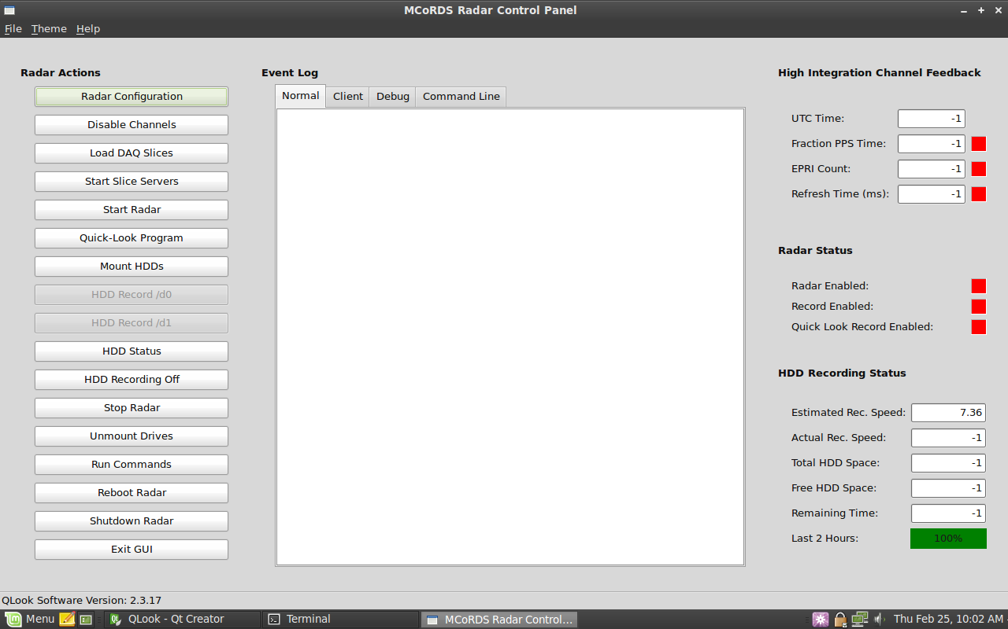
Figure 1: MCoRDS radar control panel

- Generate new config radar file if needed by clicking radar configuration and filling in the parameter settings. See section 2 for details on each parameter.
- Click Load DAQ Slices.
- Click Start Slice Servers.
- Manually change Wavegen_Shape8.wf if needed.
  - If using config file with base pulse length = 1us, copy and overwrite Wavegen_Shape8.wf with Wave_shape8_222.wf (Blackmann or maxpower)
  - If using config file with base pulse length = 2.5us, copy and overwrite Wavegen_Shape8.wf with Wave_shape8_555.wf (Blackmann or maxpower)
  - If using config file with base pulse length = 3us copy and overwrite Wavegen_Shape8.wf with Wave_shape8_666.wf (maxpower)
- Clock Mount HDDs. If one or more hard drives fail to mount, proceed to step 8, otherwise move to step 9.
------------------------------------------------------------------------------------------------------------
Hard Drives Failed to Mount
- Click shutdown the radar. Wait 30 sec for slices to actually shut down then power down digital chassis. Replace hard drive pack and return to step 1.
------------------------------------------------------------------------------------------------------------
- Click start radar. All 3 digital chassis LEDs should be on when the radar is running properly. Note: after each power cycle, the radar needs to be started 2 times to function properly. This function is built into the start radar button but the user should be aware of this if they want to manually start the radar after a power cycle.
- Open the Qlook program and make sure all channels are detected and selectable in the “Select Radar Channels to Use” section.

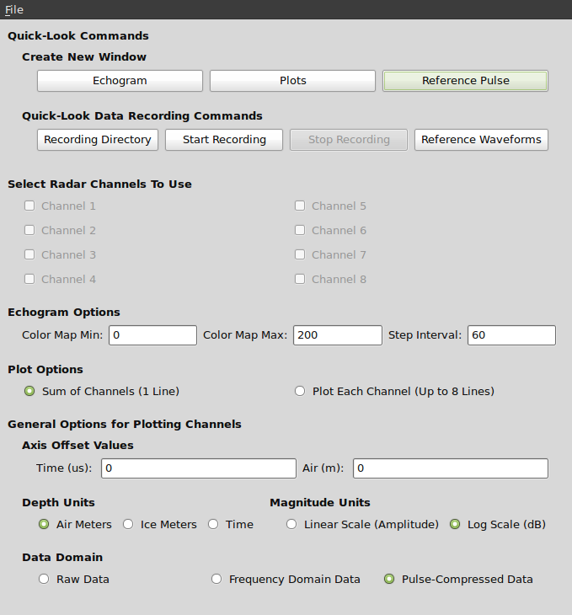
Figure 2: QLook program, noticed that all channels in “Select Radar Channels to Use” are gray, these should all be selectable if radar is running properly.

- Close Qlook and click stop radar to stop the radar. Digital chassis’ Radar Enable LED should turn off, other PLL and Power LEDs should remain on.
- Power up RF chassis.
- Click start radar. All 3 Digital chassis LEDs should come on.
- Open Qlook and make sure echogram and pulse compressed ascopes are what is expected.
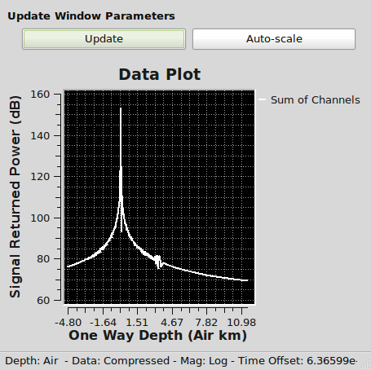
Figure 3: Sample of pulse compressed Ascope waveform during ideal loopback.

Data Recording

- Start data recording by clicking “HDD Record /d0” or “HDD Record /d1” on the MCoRDS Radar Control Panel to record raw data to the hard drive packs.
- Start Qlook data recording by clicking “Start Recording” on the Qlook program to record the high integration channel data to the computer’s hard drives.
- To stop recording click “HDD Recording Off” on the MCoRDS Radar Control Panel for hard drive pack recording.
- To stop Quick-Look data recording click “Stop Recording” on the Quick-Look Commands widow.

Radar shutdown

- Make sure all recording is stopped.
- Click “Stop Radar” to stop the radar.
- Shut off power to the RF chassis of the radar.
- At this point I would normally move the data into their own directories within each HD pack. To do this log into each slice individually. Access the harddrives by typing “cd /d0”
Use “mkdir (directory name here without quotes)” to make a directory.
Use “mv (file name here) (directory name or path here)” to move files.
Note: move large number of files with same ending using *.
- Click “Unmount Drives” to un-mount all of the harddrives. Note: If this step is performed manually, the user needs to first kill the server_rec process by logging into each DAQ slice and running “pkill server_rec” and then “umount /d#” (replace # with 0 or 1 depending on the harddrive pack used).

- asdf

Appendix

I. Low Altitude Config File

The following is an example of a working LOW ALTITUDE radar configuration file flown on the DC8 in the Chile 2009 Missions. This file is for altitudes of around 1500ft.

#############################################
# Configurations File for CReSIS Radars
#
# University of Kansas
# CReSIS
# 2335 Irving Hill Rd.
# Lawrence, KS 66045
# https://www.cresis.ku.edu/
#############################################
# Comment lines are from the pound sign to
# the end of the line
#############################################
#
# This file is generated automatically.
# It is recommended that you not hand edit
# this file. But it is written in human readable
# format on purpose, just in case.
#
#############################################

#Sampling frequency, in Hertz.
SAMPLE_FREQUENCY 111111111.11111110

#DDS frequency, in Hertz.
DDS_FREQUENCY 888888888.88888884

# PRF Desired, in Hertz
PRF 6000

# Delay from PRF Trigger, until the waveform starts coming out.
# In Seconds. Must be larger than 10.4 us to allow for updating
# the AD9910 in time.
IO_UPDATE_TIME 1.100000e-05

# Longest Pulse Duration
BASE_PULSE_LENGTH 1.000000e-06

# High Integration Channel Enable: 1=on, 0=off
HI_CH_ENA 1

# High Integration Channel rate setting
# The waveform generator will trigger a new HI cycle
# every <setting> number of EPRI cycles
HI_CH_RATE 1000

# High Integration Channel Waveform Number
HI_CH_WFNUM 2

# High Integration Channel Additional Presum Count
HI_CH_PRE_CNT 100

# High Integration Channel Readout Count
# This is the number of double-sample readouts
# e.g. a setting of 5 will read out 10 samples
HI_CH_RO_CNT 3500

#DDS Multichip Sync Value
MULTICHIP_SYNC 20

# Trigger Output Divisor
TRIG_OUT_DIV 2

# Trigger Output High Counts
TRIG_OUT_CNT_HIGH 625

# Trigger Output Inversion: 0 = Active High, 1 = Active Low
TRIG_OUT_INV 0

# Trigger Source: 0 = Internal, 1 = External Trigger Mode
TRIG_SOURCE 0

# ADC Bypass: 0 = ADC / Normal mode, 1 = internal ramp mode
ADC_BYPASS 0

# DDS Power Level Settings
DDS1_AMPLITUDE 1
DDS2_AMPLITUDE 30
DDS3_AMPLITUDE 35
DDS4_AMPLITUDE 20
DDS5_AMPLITUDE 46
DDS6_AMPLITUDE 0
DDS7_AMPLITUDE 0
DDS8_AMPLITUDE 0

# Waveform Settings
WAVEFORM 1
WAVEFORM_PRESUMS 1
WAVEFORM_TX_MASK 0
WAVEFORM_START_FREQ 189150000
WAVEFORM_STOP_FREQ 198650000
WAVEFORM_ZERO_PI_MOD true
WAVEFORM_ANGLE 0
WAVEFORM_LENGTH_MULT 1
WAVEFORM_DAQ_REC_LENGTH 6.500000e-05
WAVEFORM_DAQ_REC_DELAY 10.000000e-06
DDS 1
DDS_FREQ_START 913942197
DDS_PHASE_START_ZERO 10000
DDS_PHASE_START_PI 42768
DDS 2
DDS_FREQ_START 913942197
DDS_PHASE_START_ZERO 3000
DDS_PHASE_START_PI 35768
DDS 3
DDS_FREQ_START 913942197
DDS_PHASE_START_ZERO 2000
DDS_PHASE_START_PI 34768
DDS 4
DDS_FREQ_START 913942197
DDS_PHASE_START_ZERO 4000
DDS_PHASE_START_PI 36768
DDS 5
DDS_FREQ_START 913942197
DDS_PHASE_START_ZERO 12500
DDS_PHASE_START_PI 45268
DDS 6
DDS_FREQ_START 913942197
DDS_PHASE_START_ZERO 0
DDS_PHASE_START_PI 32768
DDS 7
DDS_FREQ_START 913942197
DDS_PHASE_START_ZERO 0
DDS_PHASE_START_PI 32768
DDS 8
DDS_FREQ_START 913942197
DDS_PHASE_START_ZERO 0
DDS_PHASE_START_PI 32768
PULSE_OUT_0_START_CNT 20
PULSE_OUT_0_WIDTH_CNT 653
PULSE_OUT_1_START_CNT 300
PULSE_OUT_1_WIDTH_CNT 359
PULSE_OUT_2_START_CNT 20
PULSE_OUT_2_WIDTH_CNT 680
PULSE_OUT_3_START_CNT 20
PULSE_OUT_3_WIDTH_CNT 1111
PULSE_OUT_4_START_CNT 492
PULSE_OUT_4_WIDTH_CNT 167
PULSE_OUT_5_START_CNT 10
PULSE_OUT_5_WIDTH_CNT 700
PULSE_OUT_6_START_CNT 20
PULSE_OUT_6_WIDTH_CNT 1111
PULSE_OUT_7_START_CNT 20
PULSE_OUT_7_WIDTH_CNT 1111
ATTEN_IF_A_CH1_ATTEN1 9
ATTEN_IF_A_CH1_ATTEN2 9
ATTEN_IF_A_CH2_ATTEN1 8
ATTEN_IF_A_CH2_ATTEN2 8
ATTEN_IF_B_CH1_ATTEN1 5
ATTEN_IF_B_CH1_ATTEN2 5
ATTEN_IF_B_CH2_ATTEN1 8
ATTEN_IF_B_CH2_ATTEN2 9
ATTEN_IF_C_CH1_ATTEN1 0
ATTEN_IF_C_CH1_ATTEN2 0
ATTEN_IF_C_CH2_ATTEN1 5
ATTEN_IF_C_CH2_ATTEN2 5
ATTEN_IF_D_CH1_ATTEN1 8
ATTEN_IF_D_CH1_ATTEN2 9
ATTEN_IF_D_CH2_ATTEN1 8
ATTEN_IF_D_CH2_ATTEN2 9

WAVEFORM 2
WAVEFORM_PRESUMS 16
WAVEFORM_TX_MASK 0
WAVEFORM_START_FREQ 189150000
WAVEFORM_STOP_FREQ 198650000
WAVEFORM_ZERO_PI_MOD true
WAVEFORM_ANGLE 0
WAVEFORM_LENGTH_MULT 10
WAVEFORM_DAQ_REC_LENGTH 6.500000e-05
WAVEFORM_DAQ_REC_DELAY 10.000000e-06
DDS 1
DDS_FREQ_START 913942197
DDS_PHASE_START_ZERO 10000
DDS_PHASE_START_PI 42768
DDS 2
DDS_FREQ_START 913942197
DDS_PHASE_START_ZERO 3000
DDS_PHASE_START_PI 35768
DDS 3
DDS_FREQ_START 913942197
DDS_PHASE_START_ZERO 2000
DDS_PHASE_START_PI 34768
DDS 4
DDS_FREQ_START 913942197
DDS_PHASE_START_ZERO 4000
DDS_PHASE_START_PI 36768
DDS 5
DDS_FREQ_START 913942197
DDS_PHASE_START_ZERO 12500
DDS_PHASE_START_PI 45268
DDS 6
DDS_FREQ_START 913942197
DDS_PHASE_START_ZERO 0
DDS_PHASE_START_PI 32768
DDS 7
DDS_FREQ_START 913942197
DDS_PHASE_START_ZERO 0
DDS_PHASE_START_PI 32768
DDS 8
DDS_FREQ_START 913942197
DDS_PHASE_START_ZERO 0
DDS_PHASE_START_PI 32768
PULSE_OUT_0_START_CNT 20
PULSE_OUT_0_WIDTH_CNT 1153
PULSE_OUT_1_START_CNT 300
PULSE_OUT_1_WIDTH_CNT 859
PULSE_OUT_2_START_CNT 20
PULSE_OUT_2_WIDTH_CNT 1236
PULSE_OUT_3_START_CNT 20
PULSE_OUT_3_WIDTH_CNT 1111
PULSE_OUT_4_START_CNT 492
PULSE_OUT_4_WIDTH_CNT 667
PULSE_OUT_5_START_CNT 10
PULSE_OUT_5_WIDTH_CNT 1200
PULSE_OUT_6_START_CNT 20
PULSE_OUT_6_WIDTH_CNT 1111
PULSE_OUT_7_START_CNT 20
PULSE_OUT_7_WIDTH_CNT 1111
ATTEN_IF_A_CH1_ATTEN1 9
ATTEN_IF_A_CH1_ATTEN2 9
ATTEN_IF_A_CH2_ATTEN1 8
ATTEN_IF_A_CH2_ATTEN2 8
ATTEN_IF_B_CH1_ATTEN1 5
ATTEN_IF_B_CH1_ATTEN2 5
ATTEN_IF_B_CH2_ATTEN1 8
ATTEN_IF_B_CH2_ATTEN2 9
ATTEN_IF_C_CH1_ATTEN1 0
ATTEN_IF_C_CH1_ATTEN2 0
ATTEN_IF_C_CH2_ATTEN1 5
ATTEN_IF_C_CH2_ATTEN2 5
ATTEN_IF_D_CH1_ATTEN1 8
ATTEN_IF_D_CH1_ATTEN2 9
ATTEN_IF_D_CH2_ATTEN1 8
ATTEN_IF_D_CH2_ATTEN2 9

II. High Altitude Config File

The following is an example of a working HIGH ALTITUDE radar configuration file flown on the DC8 in the Chile 2009 Missions. This file is for altitudes of around 35000ft.

#############################################
# Configurations File for CReSIS Radars
#
# University of Kansas
# CReSIS
# 2335 Irving Hill Rd.
# Lawrence, KS 66045
# https://www.cresis.ku.edu/
#############################################
# Comment lines are from the pound sign to
# the end of the line
#############################################
#
# This file is generated automatically.
# It is recommended that you not hand edit
# this file. But it is written in human readable
# format on purpose, just in case.
#
#############################################

#Sampling frequency, in Hertz.
SAMPLE_FREQUENCY 111111111.11111110

#DDS frequency, in Hertz.
DDS_FREQUENCY 888888888.88888884

# PRF Desired, in Hertz
PRF 6900

# Delay from PRF Trigger, until the waveform starts coming out.
# In Seconds. Must be larger than 10.4 us to allow for updating
# the AD9910 in time.
IO_UPDATE_TIME 1.100000e-05

# Longest Pulse Duration
BASE_PULSE_LENGTH 3.000000e-06

# High Integration Channel Enable: 1=on, 0=off
HI_CH_ENA 1

# High Integration Channel rate setting
# The waveform generator will trigger a new HI cycle
# every <setting> number of EPRI cycles
HI_CH_RATE 1000

# High Integration Channel Waveform Number
HI_CH_WFNUM 1

# High Integration Channel Additional Presum Count
HI_CH_PRE_CNT 150

# High Integration Channel Readout Count
# This is the number of double-sample readouts
# e.g. a setting of 5 will read out 10 samples
HI_CH_RO_CNT 4400

#DDS Multichip Sync Value
MULTICHIP_SYNC 20

# Trigger Output Divisor
TRIG_OUT_DIV 2

# Trigger Output High Counts
TRIG_OUT_CNT_HIGH 625

# Trigger Output Inversion: 0 = Active High, 1 = Active Low
TRIG_OUT_INV 0

# Trigger Source: 0 = Internal, 1 = External Trigger Mode
TRIG_SOURCE 0

# ADC Bypass: 0 = ADC / Normal mode, 1 = internal ramp mode
ADC_BYPASS 0

# DDS Power Level Settings
DDS1_AMPLITUDE 1
DDS2_AMPLITUDE 30
DDS3_AMPLITUDE 35
DDS4_AMPLITUDE 20
DDS5_AMPLITUDE 46
DDS6_AMPLITUDE 0
DDS7_AMPLITUDE 0
DDS8_AMPLITUDE 0

# Waveform Settings
WAVEFORM 1
WAVEFORM_PRESUMS 16
WAVEFORM_TX_MASK 0
WAVEFORM_START_FREQ 189150000
WAVEFORM_STOP_FREQ 198650000
WAVEFORM_ZERO_PI_MOD true
WAVEFORM_ANGLE 0
WAVEFORM_LENGTH_MULT 10
WAVEFORM_DAQ_REC_LENGTH 8.000000e-05
WAVEFORM_DAQ_REC_DELAY 5.900000e-05
DDS 1
DDS_FREQ_START 913942197
DDS_PHASE_START_ZERO 10000
DDS_PHASE_START_PI 42768
DDS 2
DDS_FREQ_START 913942197
DDS_PHASE_START_ZERO 3000
DDS_PHASE_START_PI 35768
DDS 3
DDS_FREQ_START 913942197
DDS_PHASE_START_ZERO 1000
DDS_PHASE_START_PI 33768
DDS 4
DDS_FREQ_START 913942197
DDS_PHASE_START_ZERO 2000
DDS_PHASE_START_PI 34768
DDS 5
DDS_FREQ_START 913942197
DDS_PHASE_START_ZERO 11000
DDS_PHASE_START_PI 43768
DDS 6
DDS_FREQ_START 913942197
DDS_PHASE_START_ZERO 0
DDS_PHASE_START_PI 32768
DDS 7
DDS_FREQ_START 913942197
DDS_PHASE_START_ZERO 0
DDS_PHASE_START_PI 32768
DDS 8
DDS_FREQ_START 913942197
DDS_PHASE_START_ZERO 0
DDS_PHASE_START_PI 32768
PULSE_OUT_0_START_CNT 20
PULSE_OUT_0_WIDTH_CNT 2264
PULSE_OUT_1_START_CNT 300
PULSE_OUT_1_WIDTH_CNT 1970
PULSE_OUT_2_START_CNT 20
PULSE_OUT_2_WIDTH_CNT 2547
PULSE_OUT_3_START_CNT 20
PULSE_OUT_3_WIDTH_CNT 1111
PULSE_OUT_4_START_CNT 492
PULSE_OUT_4_WIDTH_CNT 1778
PULSE_OUT_5_START_CNT 10
PULSE_OUT_5_WIDTH_CNT 2367
PULSE_OUT_6_START_CNT 20
PULSE_OUT_6_WIDTH_CNT 1111
PULSE_OUT_7_START_CNT 20
PULSE_OUT_7_WIDTH_CNT 1111
ATTEN_IF_A_CH1_ATTEN1 9
ATTEN_IF_A_CH1_ATTEN2 9
ATTEN_IF_A_CH2_ATTEN1 8
ATTEN_IF_A_CH2_ATTEN2 8
ATTEN_IF_B_CH1_ATTEN1 5
ATTEN_IF_B_CH1_ATTEN2 5
ATTEN_IF_B_CH2_ATTEN1 8
ATTEN_IF_B_CH2_ATTEN2 9
ATTEN_IF_C_CH1_ATTEN1 0
ATTEN_IF_C_CH1_ATTEN2 0
ATTEN_IF_C_CH2_ATTEN1 5
ATTEN_IF_C_CH2_ATTEN2 5
ATTEN_IF_D_CH1_ATTEN1 8
ATTEN_IF_D_CH1_ATTEN2 9
ATTEN_IF_D_CH2_ATTEN1 8
ATTEN_IF_D_CH2_ATTEN2 9

III. Timing diagram Example


