Antarctic Season 2019/20
Thwaites AeroSurvey
Science Report
10th Jan 2020
Revision: 0
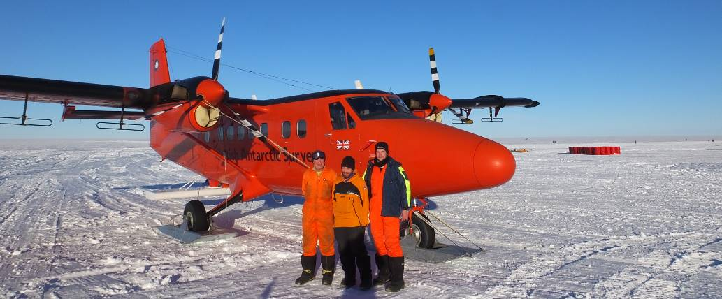

Author: Tom Jordan
Title: Aerogeophysicist (British Antarctic Survey)

Signed: 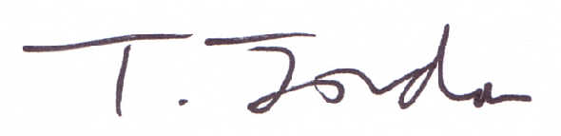 Date: 10/02/2020

Circulation/Participants List
Name | Title (Survey Role)
Carl Robinson | BAS Survey Instrumentation Engineer (Head Airborne Survey Technology) [In the field]
Ian Potten | BAS Lead Survey Pilot [In the field]
Tom Jordan | BAS Survey Scientist [In the field]
Jonathan Witherstone | BAS Survey Instrumentation Engineer [Rothera only]
John Paden | CReSIS Accumulation Radar for MELT Project
David Vaughn | Science coordinator (BAS) SCO
Ted Scambos | Science coordinator (NSF) SCO
“In the field” is a party member at the survey location.

Executive Summary
The 2019/20 BAS aerogeophysical survey used the geophysically equipped twin otter aircraft VP-FBL, to collect a series of datasets in support of the International Thwaites Glacier Collaboration (ITGC). The 2019/20 Thwaites AeroSurvey completes the 40 hour National Capability geophysical survey originally planned for the 2018/19 season. The 2018/19 survey was curtailed due to failure of the PASIN depth sounding radar system, which meant deep ice, towards the interior of the glacier catchment could not be imaged. This system was repaired and upgraded for the 2019/20 season.
Flights were designed with input from the ITGC Science Coordination Office (SCO) and members from individual projects. During survey, gravity, PASIN radar, magnetics and lidar data were collected. In addition to the ITGC National Capability flights, there were three flights flown as a part of the ITGC-funded MELT project (PI K. Nichols) using an alternative radar system from the Center for Remote Sensing of Ice Sheets (CreSIS). Flights were out of Lower Thwaites Glacier camp (LTG), located at -76.422N, -107.674E, between 25th and 30th December 2019, and on the 27th January. In addition to the core ITGC science flights various data sets were also collected opportunistically during the input and output to maximise the scientific value of the survey.
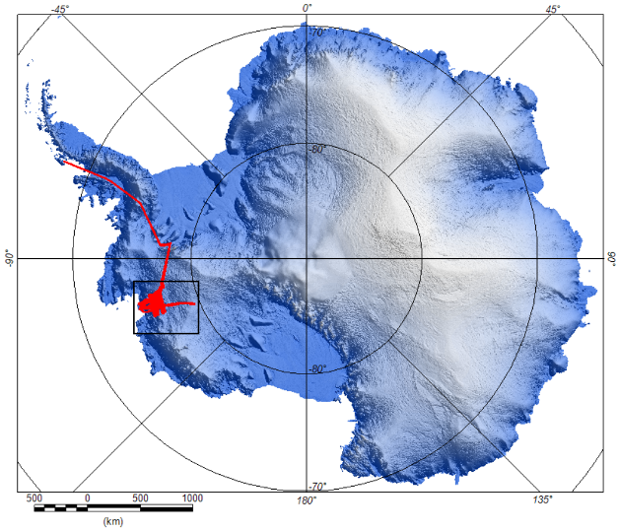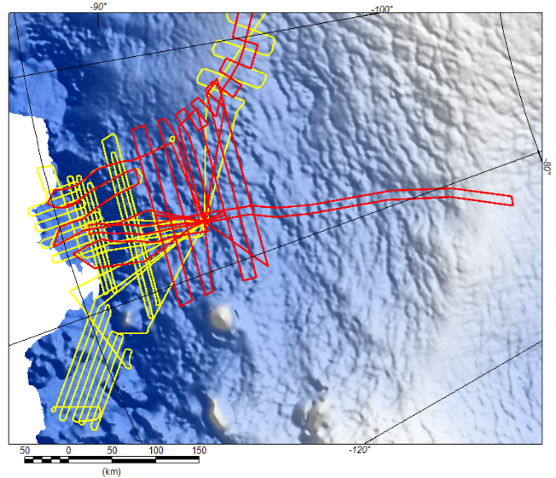
Figure 1: Thwaites 2019-20 AeroSurvey plan. a) Regional context and planned survey lines (red). b) Detail of LTG survey area, with planned 2019-20 (red) and existing 2018-19 season (yellow) flights.
Overview statistics
22 survey flights comprising: 5 ITGC core flights, 3 Melt flights, 2 transits with data for ITGC, 4 transits with opportunistic data, 4 calibration flights, 3 test flights, and 1 aborted flight. Note listed survey flights are defined as any flight where there was intention to collect geophysical data. Other transit time is not shown.
Table 1. Total time/distance flown where aerogeophysical data was collected.
 | Total | Core survey x5 | Melt x3 | Transit/margin x2 | Transit x4 | Test/Calib x7
Time (hours) | 55.92 | 15.69 | 10.5 | 7.83 | 9 | 12.9
km | 12000 | 3324 | 2137 | 1673 | 2024 | 2843

Introduction
The 2019/20 AeroSurvey completed the 40 hours of BAS Twin Otter aerogeophysical data collection in support of the International Thwaites Glacier Collaboration (ITGC). Figure 2 shows the extent of the ITGC science objectives and scope, including the eight ITGC-funded projects, PROPHET, TIME, GHOST, GHC, MELT, TARSAN, DOMINOS, and THOR. Thwaites AeroSurvey flights were designed with input from the ITGC Science Coordination Office (SCO) and individual projects. During the Thwaites AeroSurvey, gravity, radar, magnetics and lidar data were collected. In addition to the ITGC National Capability (NC) flights, three flights were flown as a part of the ITGC-funded MELT project.
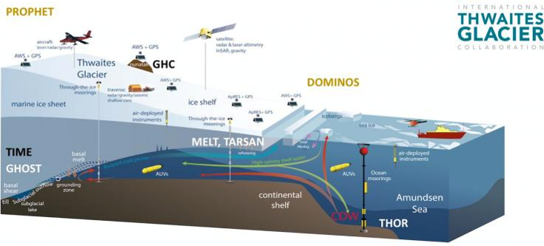
Figure 2: ITGC Overview, including airborne survey component.

Season overview and time line
The Thwaites 2019-20 season started with positioning to Punta Arenas and onward transfer with the BAS Dash 7 to Rothera Research station on the Antarctic Peninsula (Fig. 3). After initial training it took 8 days to re-role the BAS twin otter VP-FBL from cargo transport to an aerogeophysical survey aircraft. Two subsequent test flights provided calibration of the Lidar system, demonstrated that both the PASIN deep ice sounding radar and the CRESIS accumulation radar systems were working, and that gravity and magnetic potential field data were being collected. These test flights also indicated that the two radar systems interfered with each other. To preserve the integrity of the datasets it was decided that for most flights only one radar system would be run at a time.
After packing for the field there was an enforced 4 day weather delay before departing for LTG camp. This transit took 4 days, due to waiting for appropriate weather at the destination and intermediate re-fueling locations (Fossil Bluff, Sky Blu, Beamish, Fig. 4a). During the transit opportunistic data was collected over an ‘ice caldera’ on Alexander Island, along the Rutford Ice Stream, and over the Eastern Shear Margin of Thwaites Glacier.
After arriving at LTG camp on Christmas day a window of good weather allowed us to fly all the Melt and core ITGC flights over the next four days (Fig. 3 and 4b). This period of intense activity was made possible by the ground support provided by USAP. This included rapid re-fueling from bulk fuel, provision of food as needed, and a comfortable heated work/living tent for data archiving and QC.
After completing the core survey we returned to Rothera over the next two days again collecting additional data over the Eastern Shear Margin of Thwaites Glacier, along the Recovery Glacier, and over the Alexander Island “ice caldera”. In addition a smooth water calibration of the CRESIS radar system was carried out north of Alexander Island on the final return leg. The next day a short PASIN radar calibration flight was carried out over water south of Rothera research station, and the survey aircraft was de-kitted. This rapid re-role to a logistics aircraft was facilitated by preparations made during the weather delay at the start of the season.
The final Melt survey flight (T21) needed to be flown one month after the initial Melt survey flights (T06 and T07). Carl Robinson therefore returned to Antarctica at the end of January to complete this mission. Use of just the CRESIS radar system for this mission allowed for an efficient kit-out. In addition the simpler aircraft configuration allowed direct transit from Sky Blu to LTG camp and completion of the required survey flying in a single flight, reducing the amount of time spent in transit. This segment of the field season was completed in 6 days from initial kit-out to de-kit. This work included a test flight, and two calibration sequences were included on transits. The equipment onboard included the CRESIS radar, a Javad GPS receiver, and a simple low-cost INS providing heading and attitude.

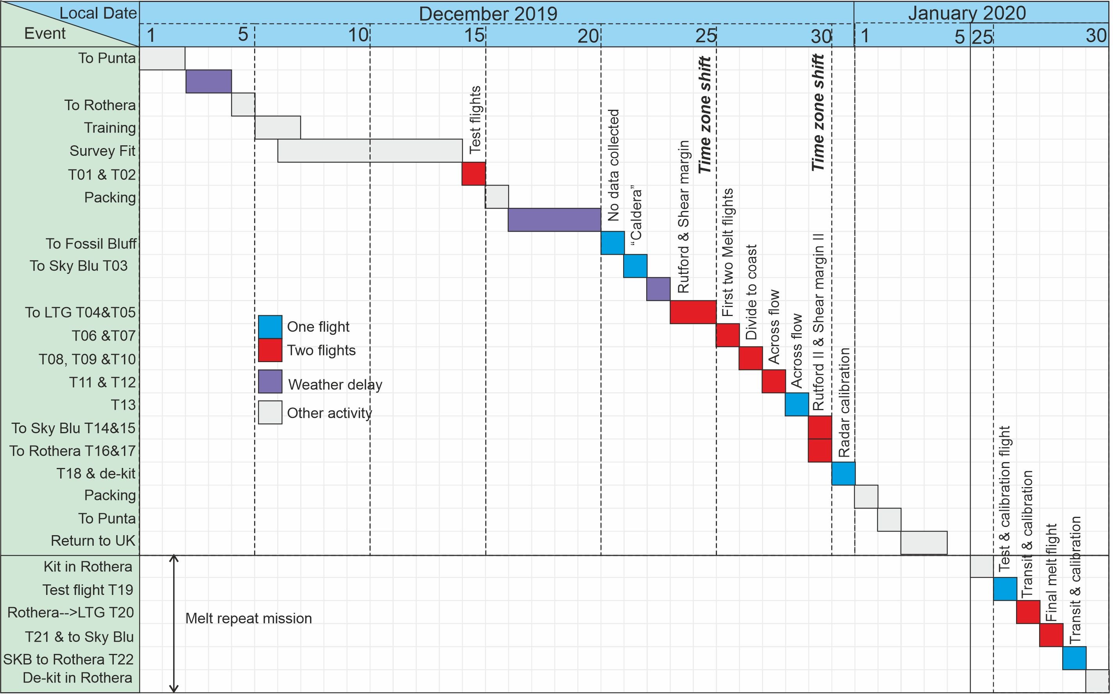
Figure. 3 Time line showing survey activity during the 2019-20 AeroSurvey. All dates are based on local time, hence the input (2 flights) appears to take 2 days, while the output (4 flights) appears to only take one day. The main survey period included flights T01 to T18. Note T08 was aborted due to a problem with the radar system and collected no useful data. Also note the flights associated with the Melt repeat mission (T19-T22) were conducted one month after the initial melt flights.
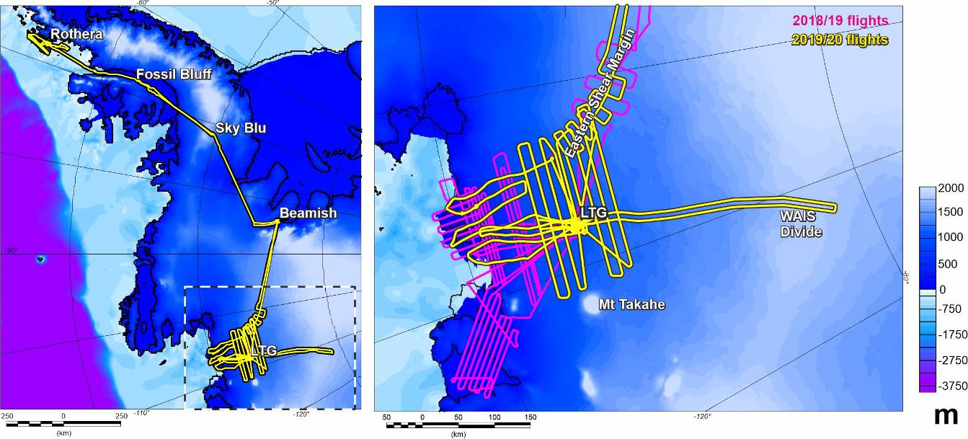
Figure. 4 Completed aerogeophysical survey flights. a) Regional view, showing input and exit route with fuel stops. b) Detail of main survey area. Note repeat Melt mission is not shown.

Ground Based Systems
Lower Thwaites Glacier (LTG) camp (Fig. 5).
The LTG camp was located at -76.422N, -107.674E, and elevation of 1181 m. The camp included a USAP provided large heated communal dinning/science weather-haven type tent, galley tent, and individual mountain tents for sleeping. Power for the communal tents was provided via an always-on ~5 kW generator, with additional heating from a reflux stove. In addition the USAP traverse was on site and engaged in snow management for the duration of the deployment. Fuelling for the survey aircraft, and a number of other logistic aircraft involved in the ITGC campaign, was from bulk fuel bladders. This system was managed by the USAP team on site, and provided efficient and quick (10-15 min) re-fuelling after every survey flight. For the later repeat Melt flight much of this infrastructure had been removed.
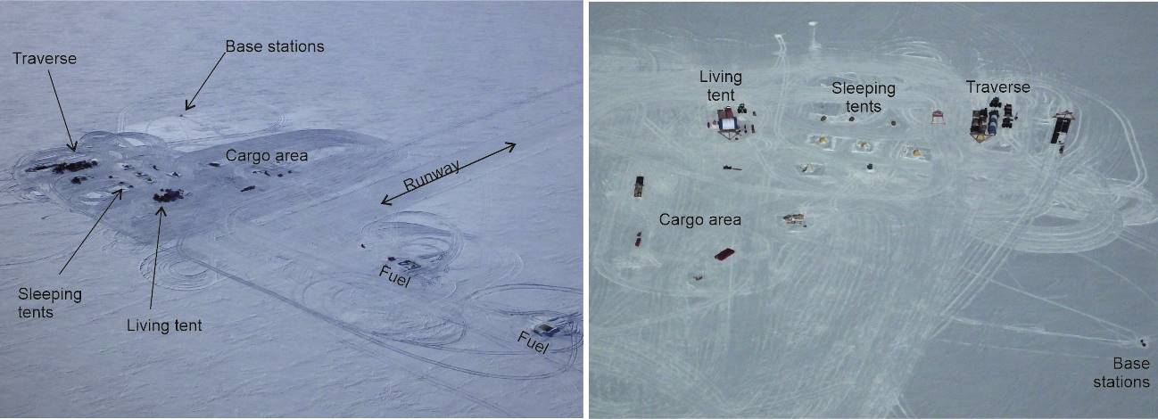
Figure 5: Aerial photos of the LTG camp, looking approximately true NW, and S respectively. Magnetic and GPS base stations were setup beside a 3-pannel solar array on the edge of the camp area (Fig. 6). The magnetic sensor was located ~10 m further out from the solar array.

Magnetic and GPS base Stations
The magnetic base station at LTG camp (Fig. 6) was setup approximately 40 m north of the communal tent on the edge of the camp area. A GEM19 was used, powered by two AGM batteries and solar panels. The magnetic base station was kept running continuously from just before our first flight from LTG until over an hour after our final flight from LTG (Fig. 7). Magnetic base station data is un-available for the input/transit flights. It should be noted that the automatic GPS time stamp did not initialise. UTC time must therefore be derived from the start time (manually added to the data header) and the time from system start subsequently recorded. Data were recorded at 30 second intervals into a single file which was recovered on system shut-down. After correcting for the mean base value (52637.74 nT), the local field varied by ~+/-50 nT across the survey period (Fig. 7).
The GPS base station receiver was a JAVAD TRIUMPH2, with data logged at 2 Hz. Logged data included GPS, GLONASS, SBAS, Galileo, and QZSS satellite systems. This integrated receiver/antenna package was placed on an empty fuel drum (Fig. 6). This situation provided a stable base, with a clear sky view, and helps provide an enhanced ground plane, theoretically improving antenna gain. In addition the drum-cap provided a constrained location for the sensor during each recording session which was repeatable to within ~1cm. Power was provided to the GPS base station from the solar array through each recording session to ensure data continuity.
Base station data was not recorded for the additional Melt re-flight as GPS positional data will be finally processed using Precise Point Positioning (PPP) processing techniques which do not require a base station.
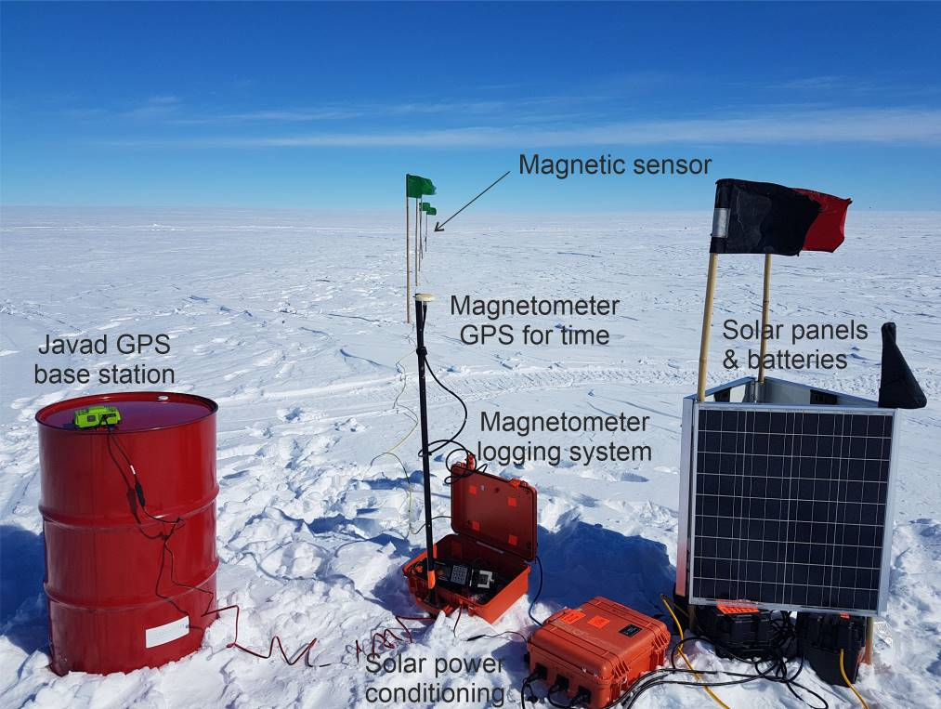
Figure 6. Base station setup. Note magnetic sensor is located >10 m from the logging and power systems to ensure a clean signal. GPS base station was located in drum cap for each flight, a location repeatable to within <1 cm.
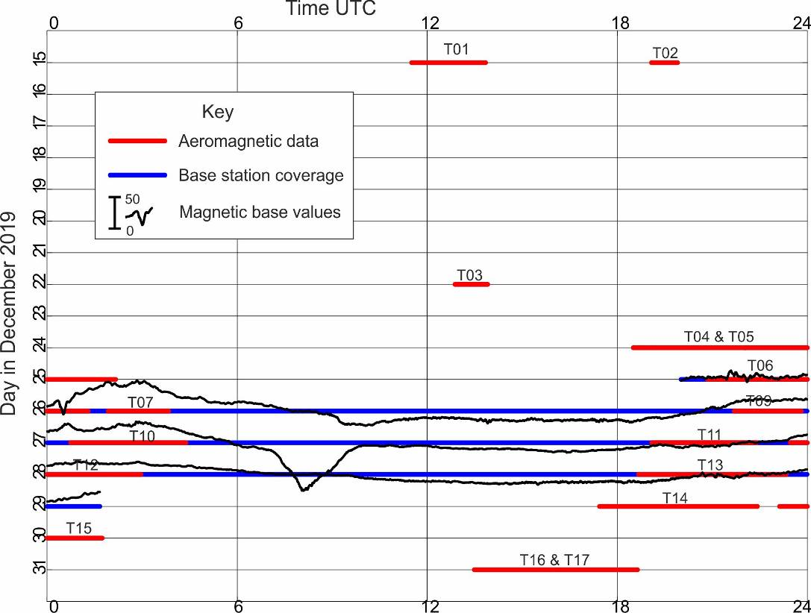
Figure 7. Aeromagnetic base station data coverage, together with base station values and flight times.

Aircraft Based Systems

Radar

PASIN2 depth sounder.
The PASIN2 radar system is the primary depth sounding radar used by the British Antarctic survey. It operates at a frequency of 150 MHz, and has an output power of up to 4 kW allowing imaging of ice over 4 km thick. It’s highly configurable design allows transmission and recording of data across multiple antennas providing the potential of both detailed across track SAR processing, and polametric observations of ice crystal fabric.
For this survey the PASIN2 system was installed in polametric configuration, together with the belly antenna. This gave a 12 antenna array, with 8 elements orientated in one direction (one wing and belly), with the opposite wing providing a 4 element array with orthogonal orientation. It was originally planned to physically re-orientate the orthogonal array for the main part of the survey giving maximum across track resolution. However, this was not possible as no aircraft engineer was available at LTG. Polametric mode was therefore pre-defined across the survey as this mode potentially provides important information about shear margin crystal fabric, while full array cross-track processing remains to be proven with the PASIN2 system.
The system was operated to transmit a sequence of five pulses in the following order across the port and starboard arrays. Port 4 µs, Starboard 4 µs, Port 4 µs (180° phase shift), Starboard 4 µs (180° phase shift), Port 1 µs. The returns of each of these pulses to each individual antenna is recorded. Combination of the 4 µs and 4 µs (180° phase shift) pulses helps minimise system noise, while the 1 µs pulse allows for resolution of finer detail of the surface and in shallow layers.
Due to a component failure on take-off for flight T08 (see Robinson 2019/20 engineering report) the belly antenna array was not used for the majority of the survey (flights T09 onward). During system operation the PASIN2 system provides a trace and waterfall display allowing continuous monitoring of system health (Fig. 8a). Subsequent quick-look processing of the data confirmed that bed elevation is resolved across the survey area, even through the complex and crevassed ice shelf region (Fig. 8b).

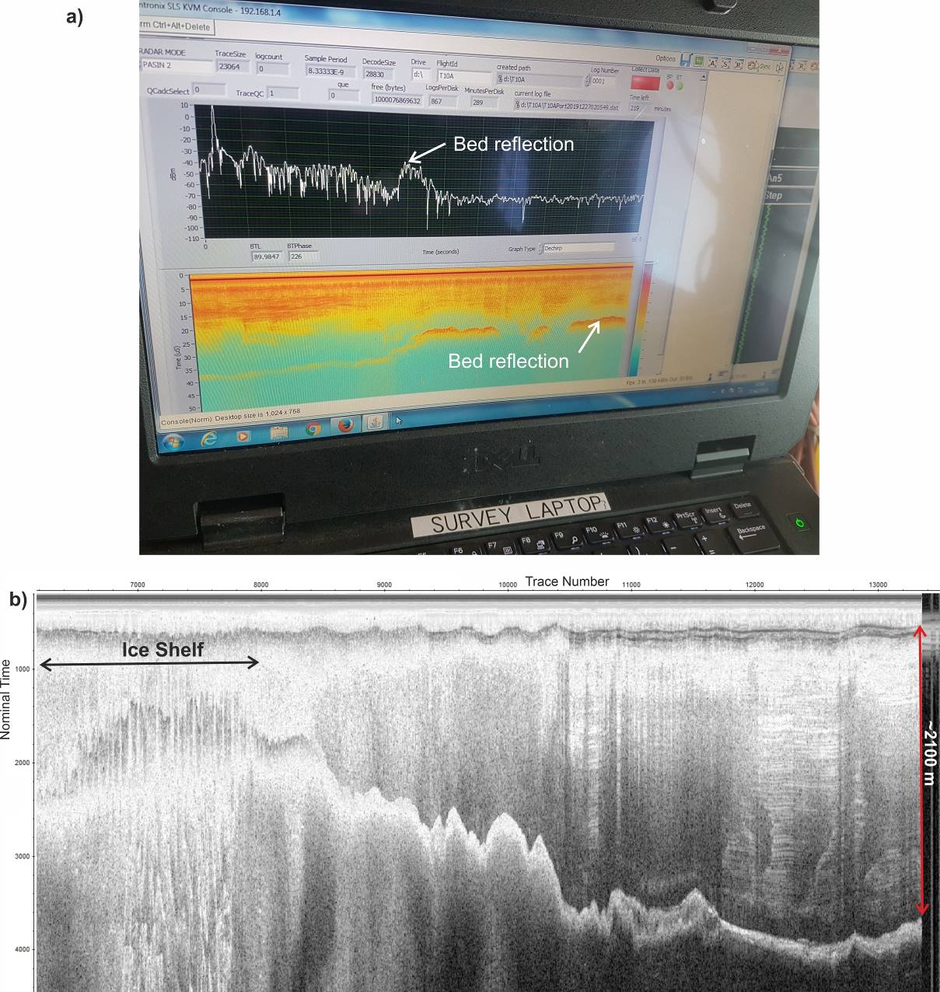
Figure 8. Examples of PASIN2radar data. a) In-flight trace and waterfall display for a flight over the western shear margin. b) Quick-look processing of PASIN2 data showing resolution of surface, bed and internal layers along track from the coast to LTG camp (~100 km long).

CReSIS Accumulation Radar
The CReSIS Accumulation Radar was used for the MELT project where detailed analysis of internal layers within shallower ice close to the grounding line is required. This was a re-flight of the survey line flown during the 18/19 season. Due to weight restrictions imposed by the aerodynamics of the belly antenna this re-flight was initially carried out across two flights. In addition the waypoints provided to the pilot were advected down-stream in proportion to the ice velocity to ensure the same ice mass was over-flown in both seasons. In addition a short section crossing the grounding-line was re-flown three times, including with a segment where the PASIN2 radar system was in operation.
Quick-look analysis (Fig. 9) confirms high-quality radar data was collected on this flight.
The Melt flight pattern was flown again at the end of January. Aircraft configuration allowed the mission to be carried out in a single flight. However, detreating weather at the camp meant the final survey leg up from the coast was cut slightly short by ~27 km.

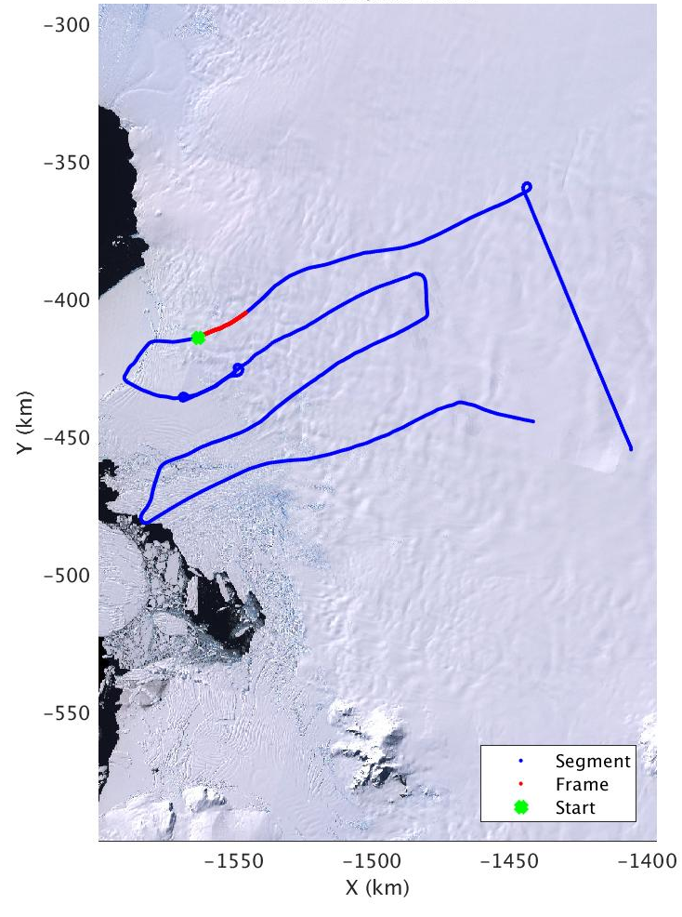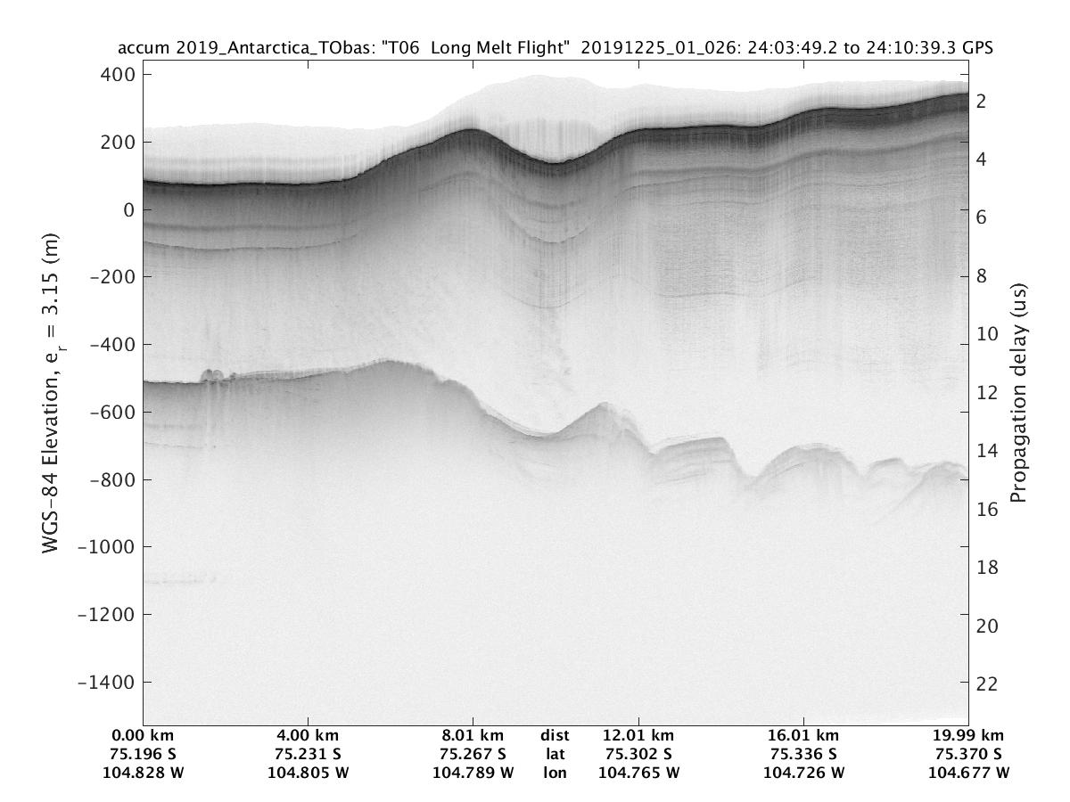
Figure 9. Example CReSIS quick-look radar image. Left hand panel shows map of flight (blue) with red section indicating displayed radargram, starting from the green point. Right hand image shows example radargram.

Gravity
Airborne gravity was measured and logged using an iMar iCORUS-02 inertial measurement system (Fig. 10). This system also provided attitude information (roll, pitch and yaw) required for processing of other data streams such as the airborne Lidar.
The strapdown gravity approach allows data collection during draped flight, removing restrictions imposed on survey design by older stabilised platform type meters. In addition shorter wavelength structures can be resolved with this type of system. The primary sensor is mounted in a thermally controlled enclosure to minimise the impact of temperature variation on the recovered gravity data set (see later discussion). Raw INS data and system temperatures were logged during survey flights both internally to the sensor, and to a tablet computer which was also the control interface with the sensor.
The gravity system generally worked well, however, on three occasions the sensor lost connection with the tablet and stopped logging. When this problem occurred a system re-start was required, meaning that there are some gaps in the both gravity and attitude data for this survey. The origin of this issue is not clear, but it may relate to a power supply problem, which needs further investigation.
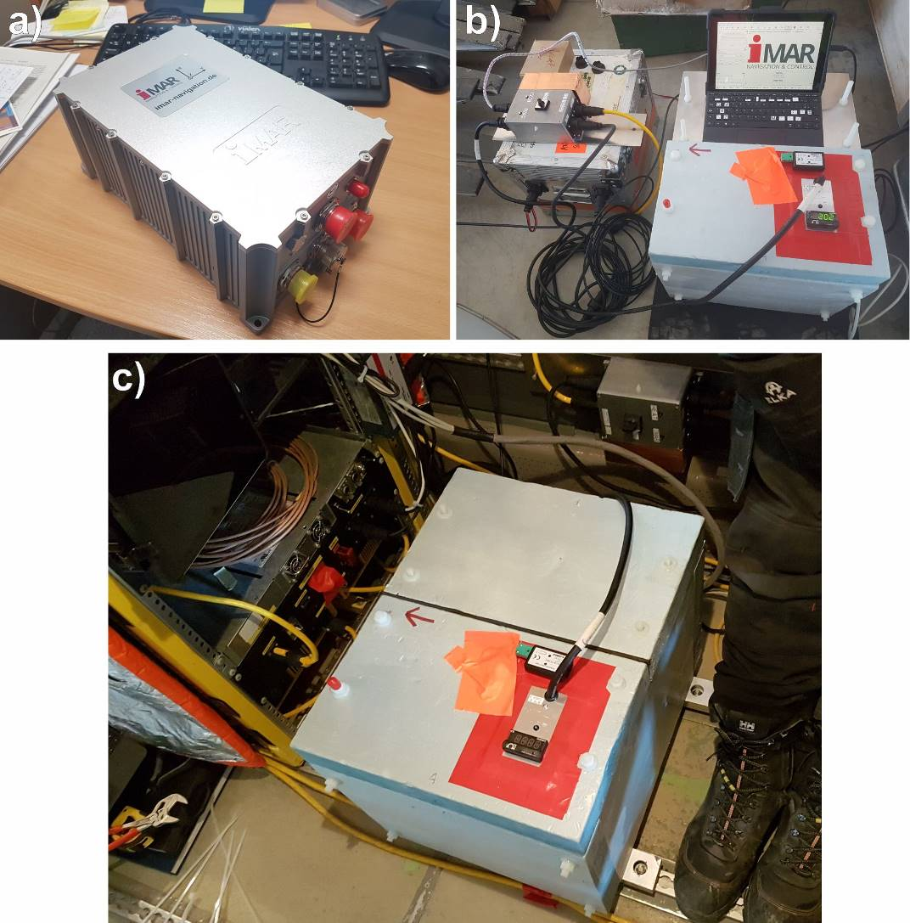
Figure 10. iCORUS-02 gravity system. a) Sensor unit. b) Gravity sensor in temperature regulated enclosure (blue box) during initial ground-test. Red arrow points forward. Power is from a 12 V battery maintained on float by a charger. Red taped area encloses thermal control system, and cabin and enclosure temperature logger. Sensor control and logging uses a tablet computer running iXCOM-CMD software. c) Gravity meter mounted in aircraft.
A key challenge to acquiring repeatable long wavelength gravity anomalies with strapdown gravity systems is operation at a constant temperature. BAS therefore developed a thermal enclosure with control loop to minimise temperature variability. During deployment of the system (it’s 1st) it became apparent that a 12 V battery alone did not sustain both the thermal stabilisation and sensor system. It was therefore decided to run the sensor continuously, while only running the thermal control when aircraft or ground AC power was available. This operational mode was possible from flight T03 to T15, from the start of the first flight each day. A set temperature of 30°C was chosen to provide a relatively quick warm up, but also to be above the ambient cabin temperature. It became apparent that this temperature was only stable if one part of the insulation on the enclosure was removed (Fig. 10b).
Across the season the ambient cabin temperature varied between -5 and 24 degrees (Fig. 11a). Without temperature stabilisation the iMar system self-heats the enclosure to ~15°C above ambient (Fig. 11b). With temperature stabilisation the enclosure maintains a temperature of ~30.8°C, with a standard deviation of 0.35°C. When controlled the enclosure temperature varies with a saw-tooth pattern with an amplitude of +/- ~0.4°C and a frequency of 5 to 10 minutes. It is apparent that when the ambient temperature gets within 15 degrees of the set temperature (i.e. above ~15°C) the enclosure temperature is not adequately controlled and varies in parallel to the outside environment (Fig. 11b). Another feature of the enclosure is that because it is not sealed the decrease in pressure on take-off leads to a rapid fall followed by a minor spike in temperature as the system re-equilibrates (Fig. 11b).
The iMar core temperature, critical for recovering stable gravity values, tracks ~17°C above the enclosure temperature, and responds slowly to external perturbation (Fig. 11). The advantage of this slow response is that the high frequency oscillation induced by the thermal control loop, or on take-off, is not seen by the system. However, the slow response means that it takes ~4.8 hours for the system to adequately equilibrate with the 5°C temperature change typically generated when the thermal control is initiated. Some thermally induced variation in gravity signals during the first flight of each day is therefore expected. Where the sensor and thermal control loop were totally powered down overnight (flights T01, T02, and T16 to T18) it is apparent that the enclosure and system temperatures fell far lower, and a state of thermal equilibrium was not achieved even after ~7 hours of operation.
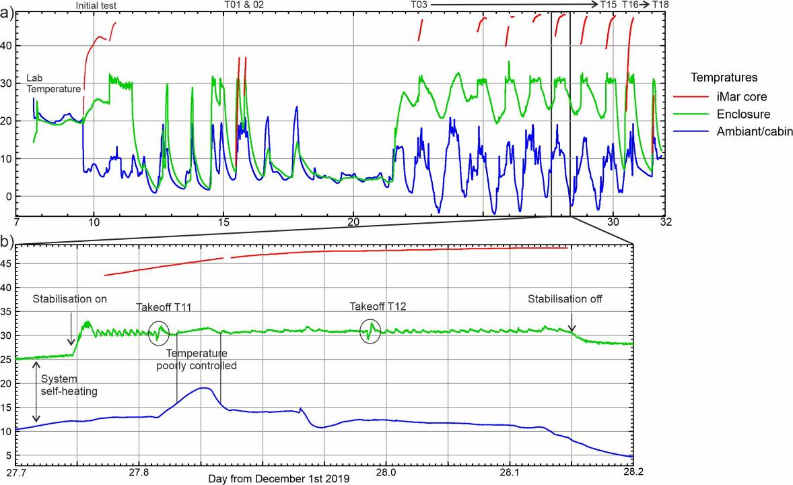
Figure 11. Temperature plots for cabin and gravity system. a) Survey-wide temperature plot. Data is from a continuous data logger (30 second interval) monitoring the outside (ambient) and inside temperature of the gravity enclosure. Additional temperature data is from the z accelerometer recorded by the iMar system. b) Detail of one day of operation showing impact of turning on and off the temperature stabilisation, a cabin temperature of >15 °C, and rapid pressure changes.
Given the results discussed above we make two key recommendations for future operations of the iMar system and thermal enclosure. First both the sensor and thermal control loop should be run continuously through-out the survey. Rigorous testing of the thermal control loop, run in conjunction with the sensor using realistic field type power supplies should be carried out to ensure this if feasible, stable and safe. Our second recommendation is that a higher thermal set point of 35 to 40°C is used allowing for stable operation in a warmer cabin.
Initial QC processing of the airborne airborne gravity data (Fig. 12) shows a good correspondence to pre-existing gravity data collected in this region. Only minor additional temperature correction and levelling will be required to generate the finalised dataset.
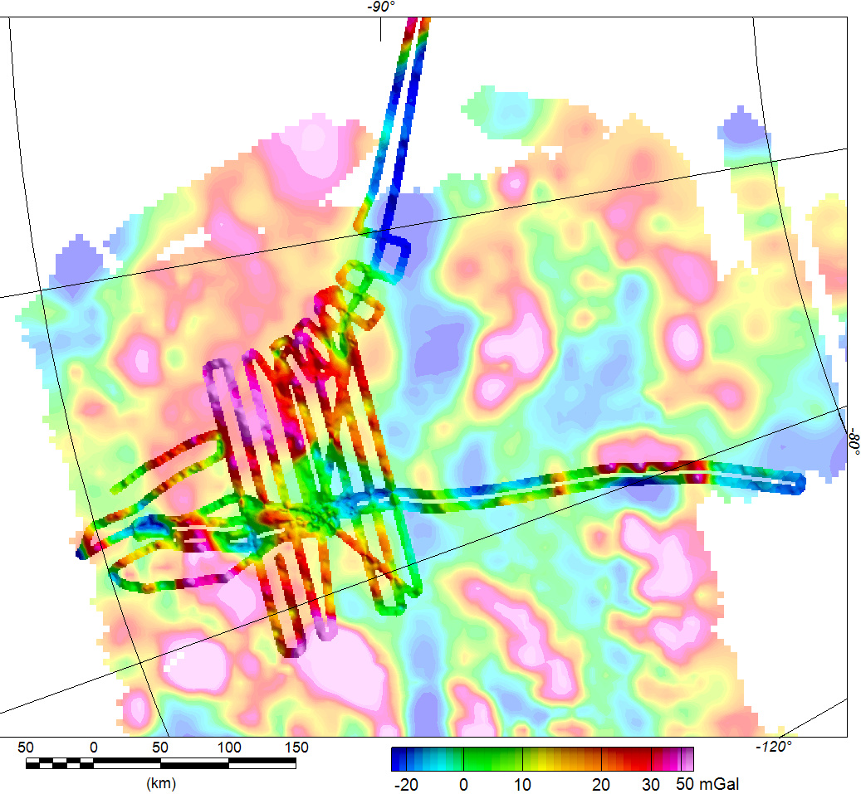
Figure 12. Map showing initial QC processed gravity data, overlain on pre-existing AGASEA gravity anomaly grid. Note a DC shift to ensure the gravity value at LTG tie down is constant after processing has been applied, but no temperature correction has been added.

Lever arms
Determination of gravity values, and accurate spatial referencing of Lidar and radar data, requires knowledge of the relative lever-arms between various sensors and GPS positioning systems. These were measured as accurately as possible using a tape-measure within the cabin of the aircraft. We estimate an error for these measurements of 5-10 cm. All measurements were then recalculated as distances from the center of observation for the iMar gravity sensor based on provided CAD drawings. This center of observation will be the location of the final integrated GPS-INS solution. In addition GPS-INS lever arms were subsequently calculated from the GPS processing software. The location of the Lidar and CReSIS radar reference points are shown in Fig. 13.
Table 2. Instrument lever arms. Measurements in meters, x +forward, y +starboard (right), z +up.
Method | Aircraft antenna name | Lever arm from iMar internal observation point | X, pos forward | Y, pos starboard | Z, pos up
Calculated by Terrapos processing | “Leica” | to Novatel GPS antenna | 0.0538 | 0.349 | 1.4803
Measured | “Leica” | to Novatel GPS antenna | 0.0684 | 0.4453 | 1.4495
Measured |  | Lidar reference point (Fig. 12a) | -2.5846 | 0.0423 | -0.2475
Measured |  | CreSIS radar reference point (Fig. 12b) | -2.7736 | 0.1733 | -0.2265
Manufacturer defined |  | Additional Lidar reference point to Lidar centre of observation | -0.05629 | -0.10328 | -0.0325
From GPS | “Ashtec” | To Javad GPS
Not used | “Camera bay”
SPAN 2nd antenna/Melt | Cabin/ Port wing

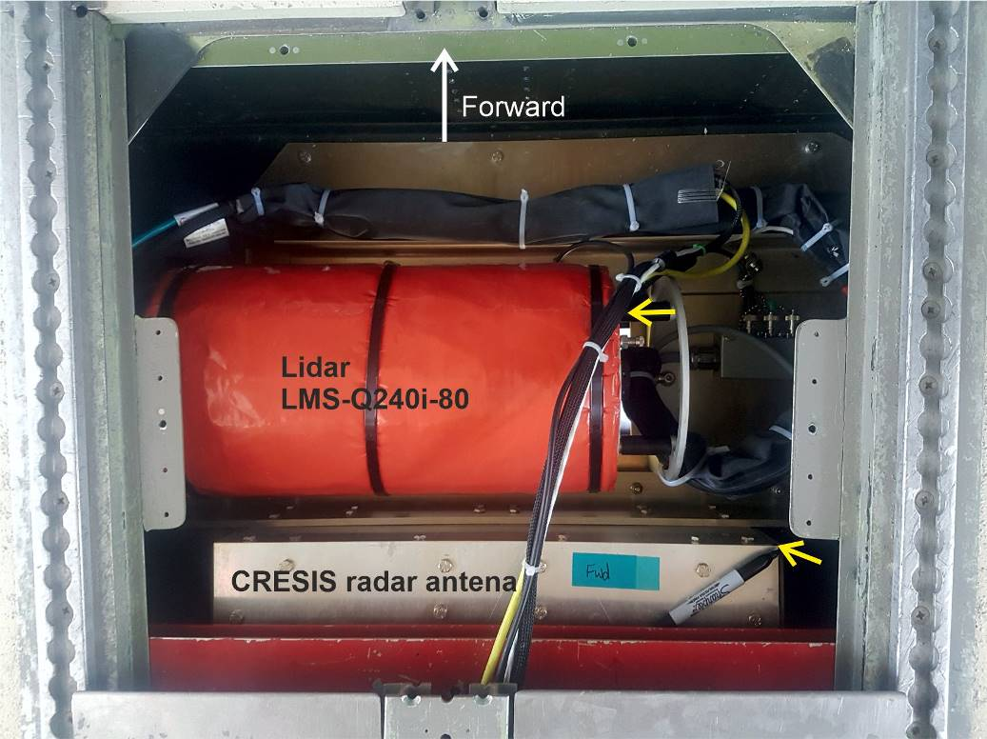
Figure 13. Lever arm measurement points (yellow arrows) for sensors in camera bay (Lidar and CRESIS radar antenna). Lidar reference point is top edge of junction of black bar with scanner body. CRESIS radar reference point is the top, forward corner of antenna housing.

Magnetometer
The aeromagnetic system utilised two Scintrex magnetometers mounted in wing-tip pods. In addition fluxgate magnetometer data from a sensor in the tail was recorded. Magnetic data for each flight was logged into a single file at 10 Hz using the Pico-Envirotec AGIS data acquisition system. Real-time GPS positional data from the Javad receiver was logged at 1Hz and integrated into the same raw data file. Each flight, prior to or during the initial stages of the first survey leg, the ‘Mag Checklist’ would be completed between Pilot and operator to ensure magnetically active aircraft systems were not inadvertently left on.
The magnetic system generally worked well. However, it was noted on install and during initial test flights that the starboard magnetic sensor was significantly noisier, with numerous spikes being present. The sensor was swapped with a spare, and various sensor orientations were tried, but the noise remained. During the main survey this noise diminished, but remains apparent. There is some correlation between heading direction and the presence of the noise, indicating that sensor orientation may be an issue. Further investigation prior to future aeromagnetic surveys is recommended. During the last 40 minutes of input flight T05 the magnetometer system froze and recorded a static value, requiring this data to be discarded.
As magnetics was a subsidiary dataset for the ITGC program no aeromagnetic compensation flight to calibrate for aircraft dynamic motions was carried out. The compensation coefficients from last season’s compensation flight were applied and appeared to be effective in some case. However, given the minimum depth to the magnetic sources is on the order of 2-3 km a 30 to 50 second low pass filter will likely remove the majority of signal induced by aircraft manoeuvres without interfering with any geological features.
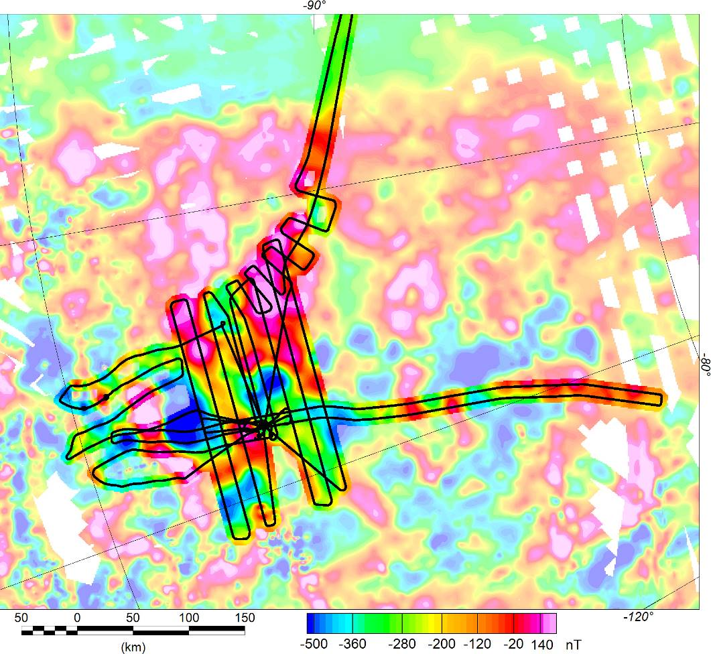
Figure 14. Aeromagnetic anomalies after QC processing to correct for the International Geomagnetic Reference Field (IGRF), compensation for aircraft dynamics, diurnal (base station) and tip tank features (strong colours). Field overlain on compilation of previous aeromagnetic data including ADMAP2 and from the 2018/19 season (pale colours). Note good correlation between anomalies.

Lidar
The installed LIDAR system was a Riegl Q240i-80 system. This system appeared to work well, with the in-flight display showing reasonable range to ground. Data for each flight (0.5 to 1.5 Gb) was archived for later detailed processing.
A Lidar calibration manoeuvre was carried out over Rothera Research station at the start of flight T01. Figure 15 shows the un-rectified Lidar data along one pass. Four passes heading N, S, E and W were flown across the station. In contrast to the typically relatively featureless, and constantly moving ice sheet, this calibration survey should allow assessment and minimisation of any residual errors in the lever arms associated with the GPS/INS/Lidar system.

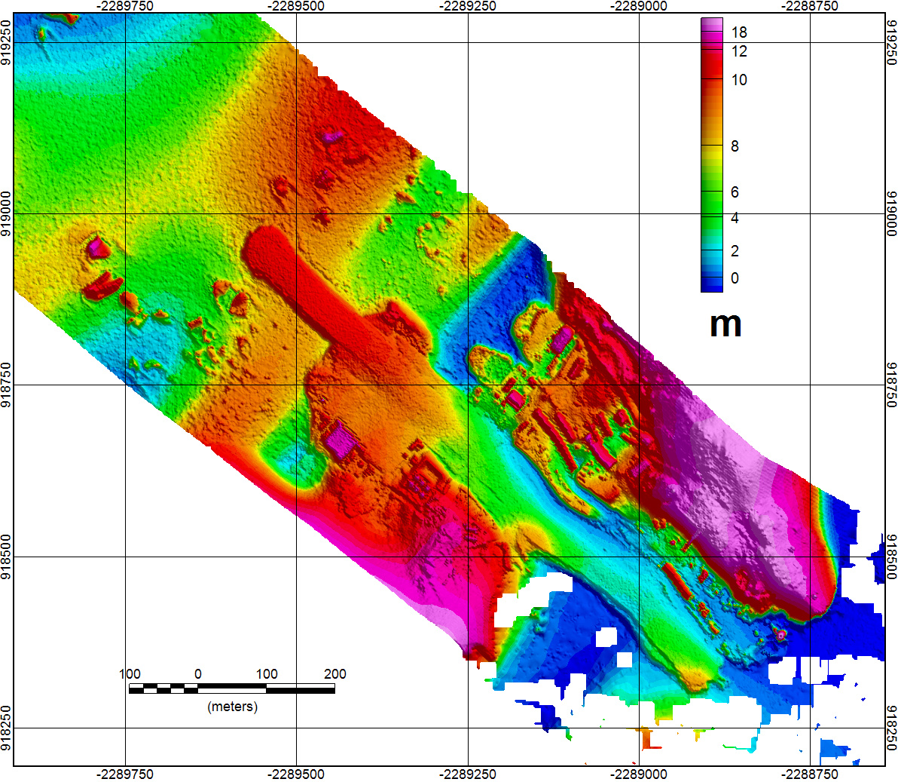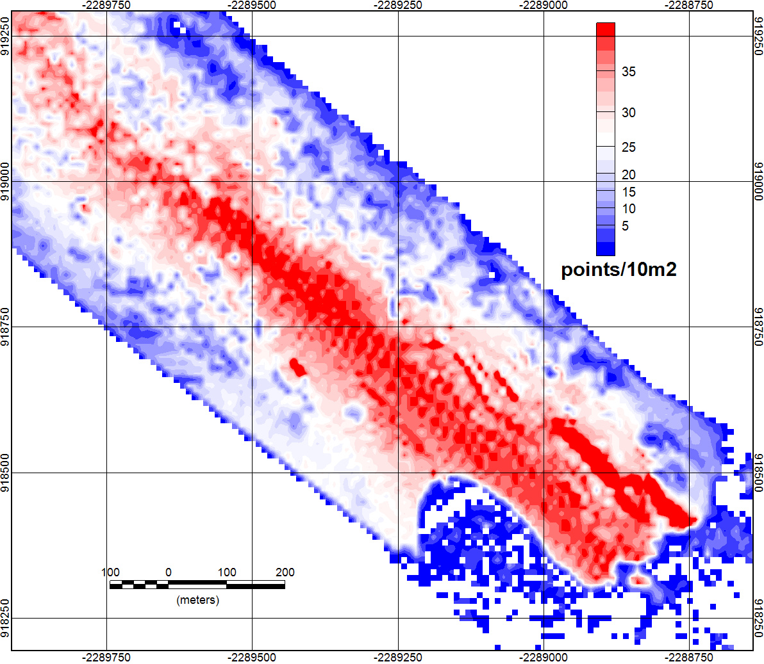
Figure 15. QC lidar data over Rothera research station. Left figure shows DEM, while right hand panel shows number of points within a 10m square. Note data is un-corrected for aircraft roll and pitch which leads to the visible across-track distortion.

GPS (roving)
The primary positioning and attitude data for this survey comes from the iCOROUS gravity (INS) system which incorporates an integrated Novatel GPS receiver. A second Novatel GPS receiver, referenced to the same antenna system, also recorded GPS data as a backup. It was intended to run a second lower specification INS (iMar FSAS) as a redundant attitude reference. Unfortunately on install the logging system did not communicate with the INS, and the FSAS system was omitted. The secondary GPS receiver provides location information in the cases noted previously where the iCOROUS system failed.
A third GPS positional data set was recorded by a Javad receiver. This used a different antenna and provides a totally separate GPS positional data-stream. The Javad receiver also provided the time stamp for the PASIN2 radar, magnetic, and Lidar systems. For the later Melt re-flight only the Javad aircraft receiver was used.
Table 2 Flights affected by loss of INS data
Flight | INS data loss start | INS data loss end
T06 | 23:24:36 | 01:42:00 (end of flight)
T09 | 22:04:00 (start of flight) | 22:12:10
T11 | 20:48:19 | 21:00:55

